Suppose we have just created an exciting new startup company called ‘Network Utopia’. The first thing we’ll surely want to do is register the domain name ‘networkutopia.com’ at a registrar.

A registrar is a commercial entity that verifies the uniqueness of the domain name, enters the domain name into the DNS database (as discussed below), and collects a small fee from we for its services. Suppose the names and IP addresses are dns1.networkutopia.com, dns2.networkutopia.com, 212.212.212.1, and 212.212.212.2. For each of these two authoritative DNS servers, the registrar would then make sure that a Type NS and a Type A record are entered into the TLD servers.   
the registrar would insert the following two resource records into the DNS system:

(networkutopia.com, dns1.networkutopia.com, NS)

(dns1.networkutopia.com, 212.212.212.1, A)

We’ll also have to make sure that the Type A resource record for our Web server www.networkutopia.com and the Type MX resource record for our mail server mail. networkutopia.com are entered into our authoritative DNS servers.

Once all of these steps are completed, people will be able to visit our Web site and send e-mail to the employees at our company.

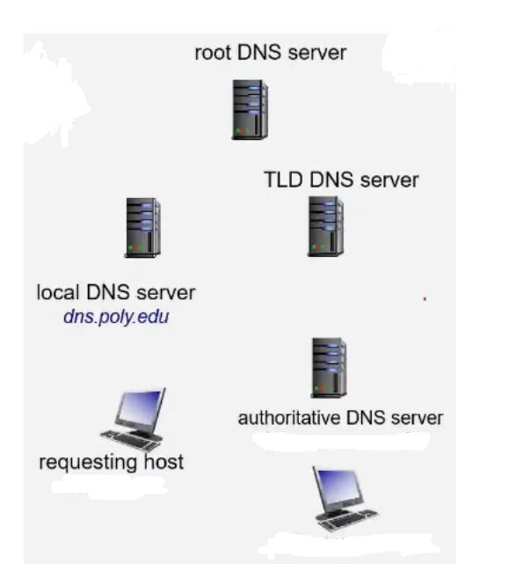  
NOW how people view the website:  
Suppose Alice in Australia wants to view the Web page www.networkutopia.com. The host will first send a DNS query to her local DNS server. The local DNS server will then contact a TLD com server. (The local DNS server will also have to contact a root DNS server if the address of a TLD com server is not cached.) This TLD server contains the Type NS and Type A resource records listed. The TLD com server sends a reply to Alice’s local DNS server, The local DNS server then sends a DNS query to 212.212.212.1, asking for the Type A record corresponding to www.networkutopia.com. This record provides the IP address of the desired Web server, say, 212.212.71.4 (authoritative DNS servers), which the local DNS server passes back to Alice’s host. Alice’s browser can now initiate a TCP connection to the host 212.212.71.4 and send an HTTP request over the connection.